JavaScript number

// var age = 20;

// alert("I am " + age + " years old");

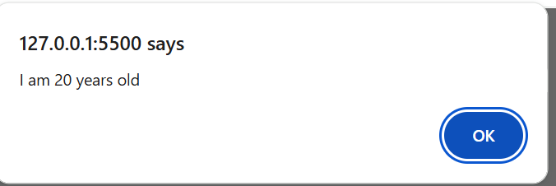

// var visitCount = 10;

// alert("You have visited this site" + visitCount + " times.")

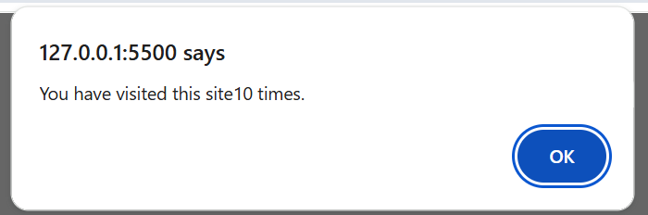

/ var birthYear = 2002;

// document.write( "   My birth year is " + birthYear + "<br>");

// document.write( "    Data type of my declared variable is number");

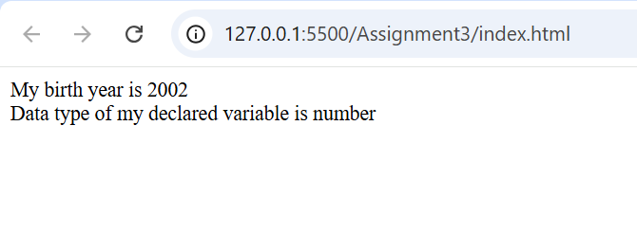

var visitorName = "John Doe";

var productTitle = "T-shirt";

var quantity = 5;

document.write( " "+ visitorName + " ordered " + quantity + " " + productTitle + "(s) on XYZ Clothing store");

